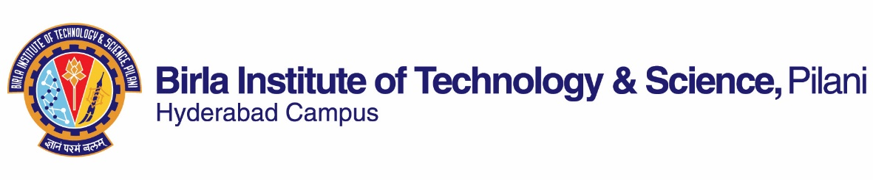

**FIRST SEMESTER 2019-2020**

# Course Handout Part II

01-08-2019

In addition to part-I (General Handout for all courses appended to the time table) this portion gives further specific details regarding the course.

*Course No.* : **CHE F214**

*Course Title* : **Engineering Chemistry**

*Instructor-in-charge* : Prof. Srikanta Dinda & Dr. Jaideep Chaterjee

**Scope and Objective of the Course:** It deals with basic principles of various branches of chemistry like physical, inorganic, organic, analytical and material chemistry. It aims to impart students an in-depth knowledge of various aspects of chemistry as applied to engineering. The course also aims to bridge the theoretical concepts and their practical engineering applications, thus highlighting the role of chemistry in the field of Chemical engineering.

Learning outcome:

After studying this course, students will be able to

* Apply their knowledge for protection of different metals from corrosion
* Apply their knowledge for analysis of compounds which will be helpful for lab oriented project work
* Think to work on bio-based polymer development to reduce environmental pollution.
* Have the knowledge on various operational issues related to large scale production of products.

**Textbooks:**

1. TB: Dr Suba Ramesh and others, Engineering Chemistry, Wiley India, 2011,1st Ed.

**Reference books**

1. R1: Perry and Green, Perry’s Chemical Engineers’ Handbook, 9th Edition, Section 2, McGraw Hill
2. R2: Dr S. S. Dara and Dr S. S. Umare, A Text book of Engineering Chemistry, S. Chand& Company Ltd,2000 1st Ed.

**Course Plan:**

|  |  |  |  |
| --- | --- | --- | --- |
| **Lec. No.** | **Learning objectives** | **Topics to be covered** | **Chapter in the Text Book** |
| 1-2 | Introduction | Electronic configuration, electronegativity, dipoles, hydrogen bonding, | TB-1 & class notes |
| 3-4 | Important Functional groups and their reactions | Alcohols, acids, amines, aldehydes and ketones, ethers. | TB-9 |
| 5-8 | Some Name reactions | Fridel-Craft acylation, Aldol condensation, Cannizzaro reaction, Hofmann rearrangement, Diels-Alder reaction, | TB-9 |
| 9-11 | Thermo-physical properties | Heat capacity, Enthalpy, viscosity, surface tension | TB-4 + class note |
| 12-14 | Phase Rule | Phase rule, Phase diagram, one-component and two component systems | TB-6 + class note |
| 15-17 | Adsorption | Adsorption isotherms, Equilibrium relation for adsorbents, Breakthrough concentration curves, Applications of Adsorption. | TB-8 |
| 18-20 | Electrochemistry | Types of electrolytes, Electrochemical cells, Galvanic cells, Nerst equation, Measurement of EMF, types of electrodes, Batteries | TB-7+ class notes |
| 21-22 | Chemical Methods of analysis | Volumetric analysis, Redox titrations, Complexometric titrations | TB-11+ class notes |
| 23-26 | Instrumental Methods of analysis | Infrared spectroscopy, NMR spectroscopy, UV-Visible spectroscopy, Chromatography, | TB-12 + class notes |
| 27-30 | Engineering Materials | Cementing materials-Lime, Refractories, Lubricants | TB-14 |
| 31-33 | Metal and Alloys | Physical properties of metals, Iron, Steel, Alloys, Alloys of steel. | TB-15 |
| 34-36 | Polymers | Classification of Polymers, Types of polymerization, Molecular weight of polymers, plastics, commercial thermoplastics and thermosetting resins, Elastomers, Synthetic rubbers, Fibres. | TB-13 |
| 37-38 | Fuel and fuel analysis | Solid, liquid and gaseous Fuel, caloric value, fuel analysis | TB-16 |
| 39-40 | Corrosion | Types of corrosion, Factors influencing rate of corrosion, Corrosion control methods, Protective coatings, | TB-18 |
| 41-42 | Water chemistry | Water treatments and analysis techniques | Class notes |

**Evaluation Scheme:**

|  |  |  |  |  |
| --- | --- | --- | --- | --- |
| **Component** | **Duration** | **Weightage (%)** | **Date & Time** | **Nature of Component** |
| Mid sem | 90 mins | 30 | 4/10, 11.00 -- 12.30 PM | CB |
| Compre Exam | 3 hrs | 40 | 11/12 AN | 30%CB +10%OB |
| Tutorial tests + quizzes (min 2 each) | - | 20 |  | OB/CB |
| 2 Assignments |  | 10 |  | OB |

**Closed Book Test:** No reference material of any kind will be permitted inside the exam hall.

**Open Book Exam:** Any printed material will be permitted. Loose papers will not be permitted.

**Chamber Consultation Hour:** To be announced in the class.

**Notices:** Notices related to the course will be displayed on Chem. Engg Notice Board/CMS

**Make-up Policy:** Make-up for the test may be granted with prior permission from the Instructor-in-charge.

**Academic Honesty and Integrity Policy:** Academic honesty and integrity are to be maintained by all the students throughout the semester and no type of academic dishonesty is acceptable.

**INSTRUCTOR-IN-CHARGE**